APPLY

*12. Find two web sites that address the issue of HTML 5 browser compatibility. Paste those links and a screen shot of the webpage into a document. Write a separate paragraph commenting about what you learned from each site.*

<http://html5test.com/index.html>

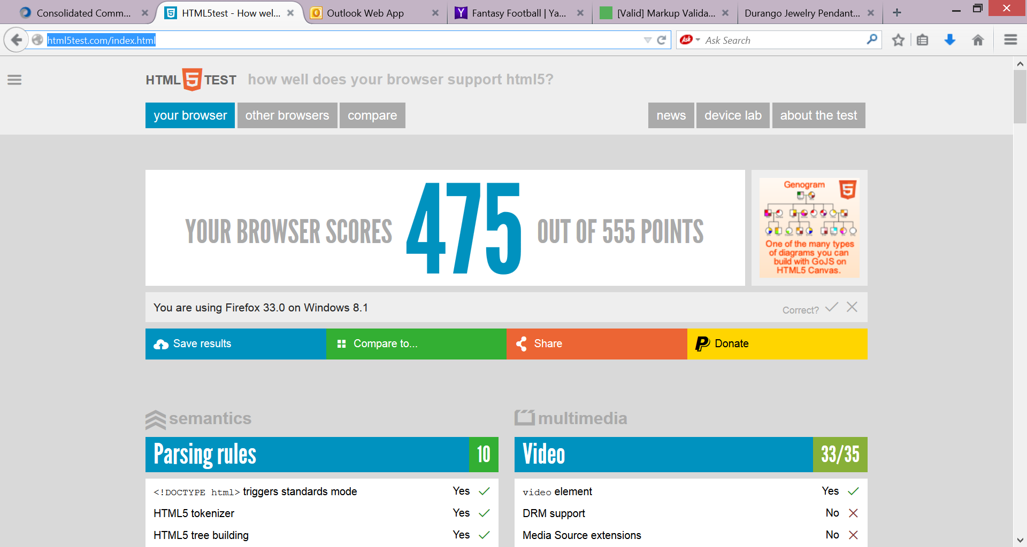

This site identifies the browser and operating system you are using and scores how well your browser supports the HTML5 specification on a scale from 0 – 555 points. It further categorizes the HTML5 specification into several categories such as semantics, multimedia, 3D graphics, and more.

2. <http://caniuse.com/#feat=html5semantic>

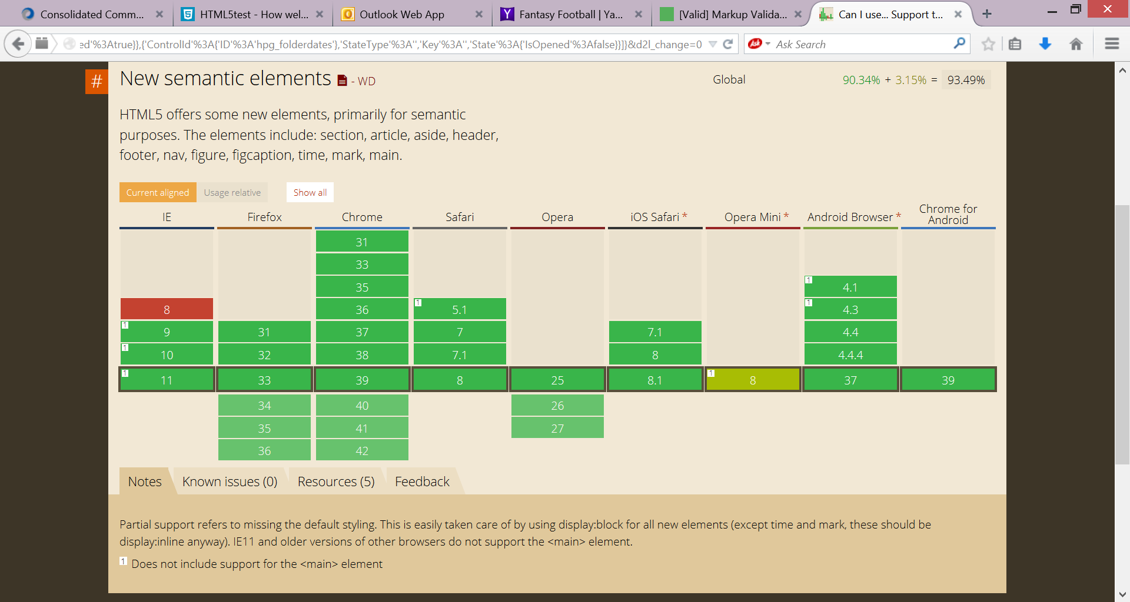

This site graphically displays the major browsers, as well as which version supports the new semantic elements of section, article, aside, header, footer, nav, figure, figcaption, time, mark, main. Hover over a block to display a tooltip showing global browser usage. You can also import the statistics for just the United States of America if desired.

1. *When is the div element used within a webpage written with html5 tags?*

The div element is still used when you want to identify content that does not have a corresponding semantic html5 tag.

1. *What are the html5 semantic tags?*

section, article, aside, header, footer, nav, figure, figcaption, time, mark, main

1. *What is the primary advantage and disadvantage of using the <main> tag vs. <div id="main">.*

The primary advantage of using the <main> tag (or any html5 semantic tag) is that it better describes the content as compared to the nonsemantic <div> tag. Using the most semantically precise tag allows people, machines, and software programs (the entire body of the "Internet of Things") to better understand the purpose of the content on the page.

The primary disadvantage of using the <main> tag (or any html5 semantic tag) is that not all browsers have fully implemented support for the tag which means that the content on the page may not be displayed as intended.

EXTEND

*15. The html validator at* [*http://validator.w3.org*](http://validator.w3.org) *allows you to validate a webpage by entering a URL, uploading a file, or directly inputting the code into the validation window. Which method(s) does the link checker at* [*http://validator.w3.org/linkcheck*](http://validator.w3.org/linkcheck) *use?*

The w3 link checker uses the **URL** of a page to check the links between pages on a website and other resources. You cannot use the link check validator to check links by file upload or direct input.

ANALYZE, CORRECT, IMPROVE

<li><a href="http://www.w3schools.com/">w3schools</a></li>

Claims to be "the world's largest web development site". Provides reference material and tutorials for many web technologies including html, css, JavaScript and more.

<li><a href="http://www.codecademy.com/">codecademy</a></li>

Free education on how to code in many different web-related technologies including html, css, JavaScript, and more.

<li><a href="http://caniuse.com/">caniuse</a></li>

"Can I use" provides up-to-date browser support tables for support of front-end web technologies on desktop and mobile web browsers.

<li><a href="http://media.mediatemple.netdna-cdn.com/wp-content/uploads/images/html5-cheat-sheet/html5-cheat-sheet.pdf">html5 reference sheet</a></li>

Printable html5 pdf reference guide

<li><a href="http://html5doctor.com/">html5doctor</a></li>

Online resource to learn more about the hows and whys of implementing HTML5.

<li><a href="http://www.codeschool.com/">codeschool</a></li>

" Code School teaches web technologies in the comfort of your browser with video lessons, coding challenges, and screencasts."

<li><a href="http://stackoverflow.com/">stackoverflow</a></li>

"Stack Overflow is a question and answer site for professional and enthusiast programmers. It's 100% free, no registration required. "

<li><a href="http://www.theodinproject.com/">theodinproject</a></li>

"Learn Web Development for free"

In the Lab

Lab 1

*Current "best practice" conventions code the links in the <nav> section as list items <li>, within an unordered list, <ul> versus paragraph content <p> or heading content <h1> through <h6>. Why?*

The items within the navigation area are commonly coded as list items within an unordered list because the content, the links *are* a list. The content cannot be described as paragraphs or headings.

Lab 2

*It’s easy to confuse head, header, and heading html elements. Describe the purpose for each.*

The <head> … </head> tags are required tags for each html webpage. They contain information such as the title of the page and meta tag information that contains information *about* the page.

The <header>….</header> tags are used to define or 'mark up' the content within the body of the webpage that constitutes the header for the page. Typically the header section contains the company name, logo, and tagline.

Heading tags such as <h1>…</h1>, <h2>…</h2>, <h3>…</h3>, <h4>…</h4>, <h5>…</h5>, and <h6>…</h6> are for short titles or headings that typically precede paragraphs of content. h1 represents the most important or highest level heading. The heading tags progress from h1 through h6 which represents the least important or lowest level heading.

Lab 3

*Identify three problems that might occur for a web developer if the html terminology and syntax discussed in this exercise are not understood.*

Learning the terminology and syntax of any programming language is critical for success. Problems that might occur for a web developer without this knowledge include:

* Errors will be introduced in the file which can cause the content to be rendered inconsistently or incorrectly.
* Effective communication between employees is difficult.
* Reference material cannot be efficiently found.
* Work performance suffers.

Consider this: your turn

Personal

*Use your favorite search engine to find articles on search engine optimization, SEO. Identify three tips that you can add to your web page to improve its SEO performance.*

From: Google's Search Engine Optimization Guide: <http://static.googleusercontent.com/media/www.google.com/en/us/webmasters/docs/search-engine-optimization-starter-guide.pdf>

1. Create unique, accurate page titles.
2. Make use of the "description" meta tag.
3. Improve the structure of your URLS.
4. Make your sites easy to navigate.
5. Offer quality content and services.
6. Write better anchor text.
7. Optimize the use of images.
8. Using heading tags appropriately.
9. Make effective use of robots.txt.
10. Be aware of rel="nofollow" for links.
11. Notify Google of mobile sites.
12. Guide mobile users accurately.
13. Promote your website in the right ways.
14. Make use of free webmaster tools.

Professional

(See the testimonials.html solution file.)

Collaboration

Part 2: [CT] Any time you gather information or images from the Web, fair use and copyright laws and ethics come into play. Work with your instructor to learn the copyright policies that apply to all of the exercises for this class.

Johnson County Community College copyright policies:

<http://www.jccc.edu/policy_statements/copyright/>

Stanford University Academic and Educational Permissions:

http://fairuse.stanford.edu/overview/academic-and-educational-permissions/